CS 255 System Design Document - Cochrane

UML Diagrams

UML Use Case Diagram

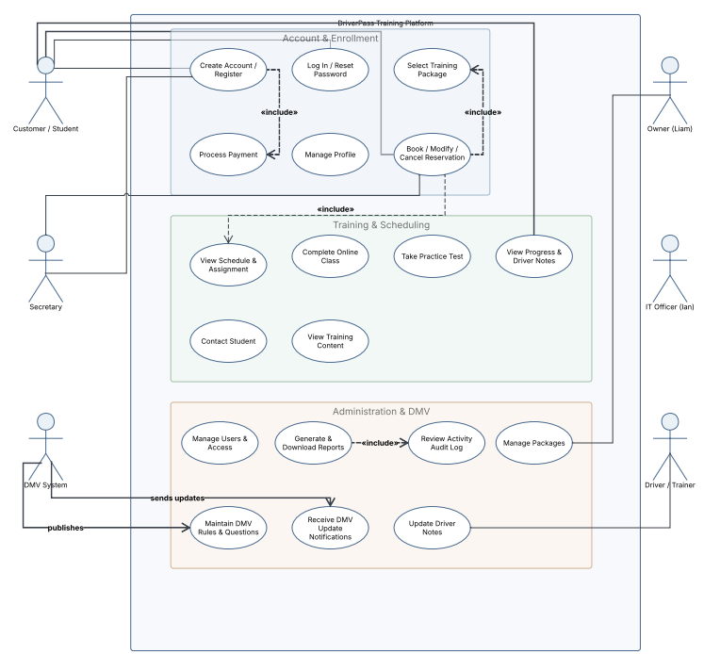

UML Activity Diagrams

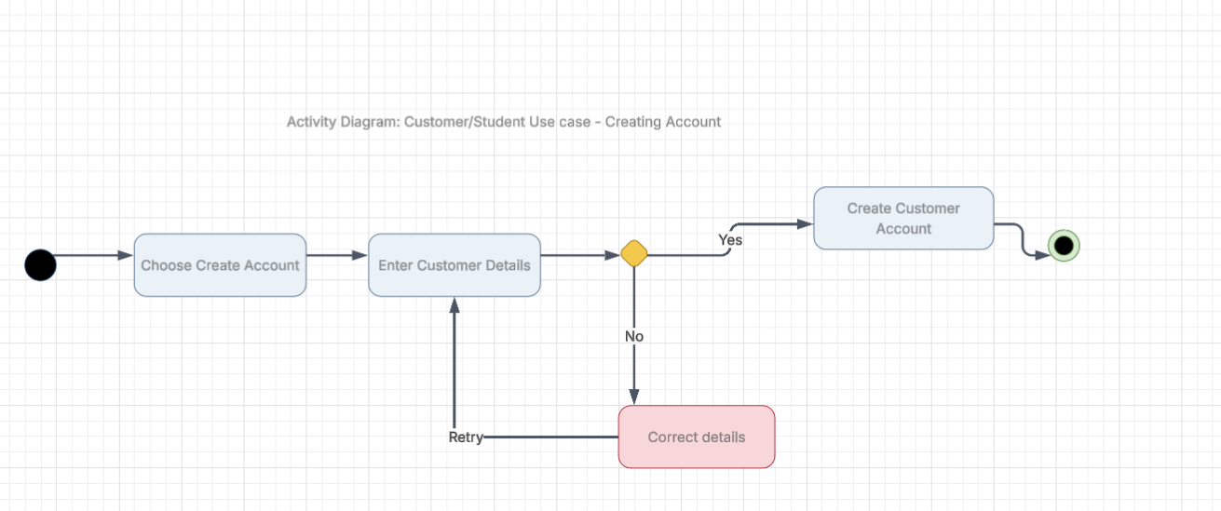

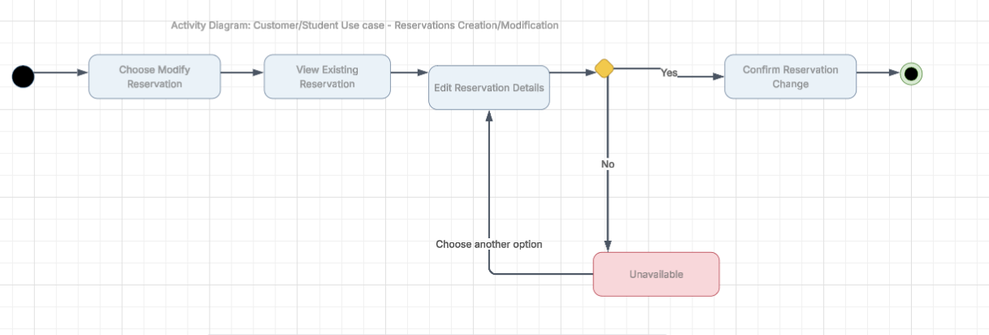

UML Sequence Diagram
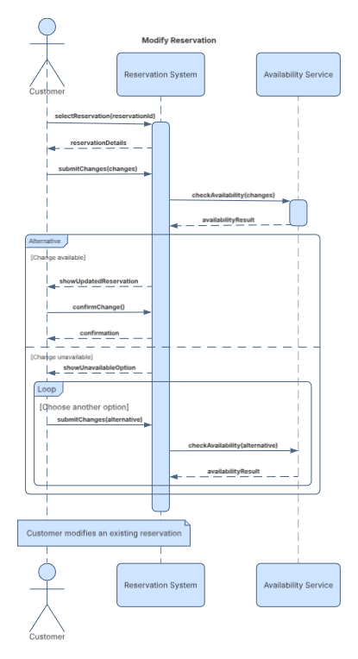

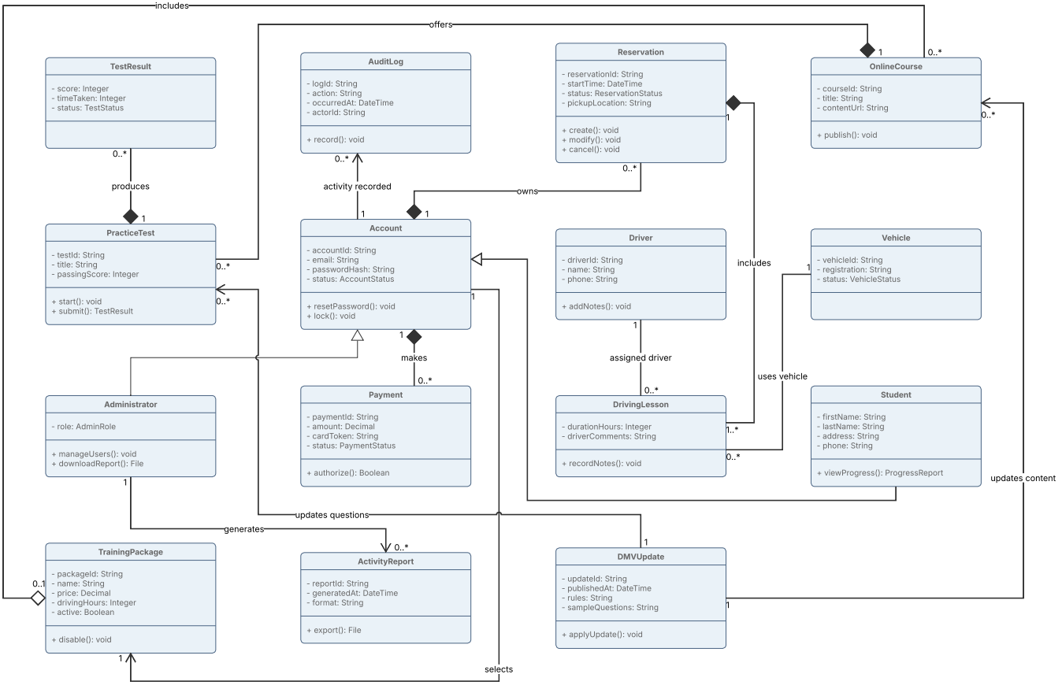
UML Class Diagram

Technical Requirements
- Infrastructure:
  - Cloud-Based Hosting infrastructure: as the platform is designed and intended to be cloud based, so leased or rented cloud infrastructure or on premise cloud hosting infrastructure and hardware will enable the system to be created according to the designed UML Diagrams and client’s intent.

  - Offline Data Accessibility: System Owner requires the ability to access system data anywhere online using his computer or mobile device so compressed, downloadable reports, logging and data needs to be able to created upon request.
- Software:
  - Web Framework: The platform and system’s capabilities and uses cases will require a multiple tiered platform architecture for hosting the services and web applications for the users, system administrators and clients to access the platform at different areas and tiers, including systems to handle user creation, scheduling, DMV integration, reports and accessing data

  - DMV Integration: DMV Policy updates will require specialized web infrastructure or capabilities to pull in near real time from the DMV systems to ensure users receive accurate and timely information as it is updated to ensure maximum efficacy of the platform and to mitigate users operating on stale information

  - Reporting Tools: System logs and reports need to be packaged in a format compatible with the clients request for Microsoft Excel use, the output data needs to be formatted and structured, once pulled from the database it will need converted to .csv or .xlsx

- Hardware:
  - Client: Clients and users will access the platform from mobile devices including Android, Apple Mobile platforms as well as Microsoft, Apple, or Linux laptops and desktops, all use cases and access platforms will require a modern web browser

  - Fleet: Vehicle fleet for DriverPass will need to include driver assignment as well as the ability to follow customer reservations and time slots, mobile devices with compatible browsers integrated into the vehicle such as a ToughBook or tablet will be assigned to each vehicle and have cellular data to ensure maximum uptime

